**MEMO**

To: Jack Eynon

From: Holly White

CC: George Joyner, Katy West, Charlton Godwin

Date: April 17, 2020

Subject: P100-Albemarle Sound Data Request

Hi Jack,

I have processed your data request to your specifications. Included in your request are the seine (Gear1=311) stations in the western portion of the Albemarle Sound from 1972 to 2019. These stations are used to calculate juvenile abundance for striped bass, blueback herring, and alewife. American shad are currently undergoing a benchmark stock assessment (summer 2020 publication), conducted by the Atlantic States Marine Fisheries Commission. A combination of the river herring and striped bass stations were evaluated to calculate a juvenile index for American shad in the Albemarle Sound, something we have not previously had.

The request does not contain all variable fields collected under Program 100. I have limited the request to the variables that are used to calculate juvenile abundance for river herring, some environmental parameters such as temp, salinity, conductivity, DO are included. Please see descriptions of variable fields below in Table 1. Stations were included in your request and can be found in Table 2. Figure 1 is a map of the western Albemarle Sound, containing all stations in the request highlighted by station type river herring or striped bass.

River Herring Seine

Eleven seine stations were sampled by DMF monthly in the western Albemarle Sound area during June-October, from 1972-present. The gear used is a ¼ inch stretch mesh 60ft long 6ft tall bag seine with a 1/8inch stretch mesh 6ft by 6ft by 6ft square bag (Gear1=311). One unit of effort is one haul of the seine. Each unique ‘control1’ is equal to one unit of effort. Samples were sorted by species and 30 randomly selected individuals of each alosine species present were measured. Other species present were also noted. Water temperature, salinity, and other environmental characteristics were measured and recorded. For river herring the first pull of each month is used to calculate the juvenile abundance index. If ‘quad’ equals blank or 1, the sample is the first pull of the month. The stations sampled are 48S, 56S, 47S, 46S, 128S, 85S, 84S, 126S, 39S, 130S, and 127S.

Station 9s is not included in the eleven stations used to calculate the juvenile index for river herring. This station is an exploratory station for American shad and has a much shorter time-series (2000’s-present) compared to the eleven core stations.

Stiped Bass Seine

Striped bass seines (9 stations) have been conducted since 1993 at nine stations spread out over the western portion of Albemarle Sound. These seines are completed weekly starting from the first week of June for six weeks. The gear used is the same seine gear (Gear1=311) described above for river herring seines. The stations sampled are 49S, 46S, 153S, 163S, 129S, 152S, 128S, 162S, and 139S.

Species = 8835020102, striped bass

I have compiled your data into a .csv file for ease of transmittal. Variable fields ‘control1’, ‘location’, and ‘control3’ have leading zeros, if uploading into excel you may want to upload these columns as text. These data while considered final, may contain errors, when conducting your analysis if you find questionable data or errors, please share those with me via e-mail at [Holly.White@ncdenr.gov](mailto:Holly.White@ncdenr.gov).

Also, we request that this data set are to be used only by the you and are not to be distributed to other users who may not be equally aware of the background and caveat I have provided to you. We would appreciate receiving a copy of any publications that may result using DMF data, and we request any reporting our DMF data should acknowledge the Division of Marine Fisheries as the source of data and indicate that the analyses and conclusions resulting from the non-Division use of the data are not necessarily those of the Division.

Table 1. Variable field names and descriptions used in data request, April 2020.

|  |  |  |  |
| --- | --- | --- | --- |
| Variable | Description | Variable | Description |
| control1 | Unique Identifier | surdo | water surface disolved oxygen-mg/L |
| program | 100 | botdo | water bottom disolved oxygen-mg/L |
| year | 1972-2019 | control3 | Unique Identifier used to calculate abundance, created by combining control1+01+species+spstatus |
| month | ALL | species | unique species code |
| day | ALL | spstatus | 0=combined, 1=young of year, 2=adult |
| station | Where the sample is collected | colnum | total number of species per status |
| location | Unique waterbody code | samnum | number of species per status in sampling unit |
| quad | Record blank or 1 for first time station pulled in month, additional pulls equal 2 | subnum | number of species per status measured in the sampling unit |
| gear1 | 311-beach seine | frequenc | number of occurrences of like data |
| surtemp | water surface temp-C | FL_mm | fork length, millimeters |
| bottemp | water bottom temp-C | TL_mm | total length, millimeters |
| sursal | water surface salinity-ppt | weight | grams |
| botsal | water bottom salinity-ppt | sex | 1=male, 2=female, 3=unknown |
| SurCond | water surface conductivity-microsiemens or millisiemens if over 9999 microsiemens | Species_name | If species code equals alosine species, name of alosine species added. If blank not blueback, alewife, or American shad |
| Botcond | water bottom conductivity-microsiemens or millisiemens if over 9999 microsiemens | Station_name | STB_Seine=station used in striped bass JAI; RH_Seine=Station used in river herring JAI; STB&RH_Seine=station used in both JAI calculations |

Table 2. P100 station GIS information, April 2020.

|  |  |  |  |  |  |  |  |
| --- | --- | --- | --- | --- | --- | --- | --- |
| STATION | PROGRAM | LONG_DD | LAT_DD | LONGITUDE | LATITUDE | COUNTY | LOCATION |
| 126S | 100 | -76.341 | 36.088 | 76° 20' 28.752" W | 36° 05' 17.556" N | PERQUIMANS | 0200090000 |
| 127S | 100 | -76.513 | 36.007 | 76° 30' 45.504" W | 36° 00' 25.632" N | CHOWAN | 0200070000 |
| 128S | 100 | -76.708 | 35.972 | 76° 42' 28.8" W | 35° 58' 20.568" N | BERTIE | 0209000000 |
| 129S | 100 | -76.608 | 35.936 | 76° 36' 28.8" W | 35 ° 56' 9.6" N | WASHINGTON | 0200040000 |
| 130S | 100 | -76.489 | 35.96 | 76° 29' 20.796" W | 35° 57' 35.568" N | WASHINGTON | 0200080000 |
| 139S | 100 | -76.685 | 36.003 | 76° 41' 4.776" W | 36° 00' 9.54" N | BERTIE | 0200020000 |
| 153S | 100 | -76.582 | 36.012 | 76° 34' 54.264" W | 36° 00' 42.984" N | CHOWAN | 0200030000 |
| 163S | 100 | -76.525 | 36.003 | 76° 31' 28.812" W | 36° 00' 10.584" N | CHOWAN | 0200050000 |
| 163S | 100 | -76.56 | 36.011 | 76° 33' 36.72" W | 36° 00' 37.836" N | CHOWAN | 0200050000 |
| 46S | 100 | -76.705 | 36.043 | 76° 42' 19.404" W | 36° 02' 33.324" N | BERTIE | 0200020000 |
| 47S | 100 | -76.737 | 36.111 | 76° 44' 11.616" W | 36° 06' 40.464" W | HERTFORD | 0208000200 |
| 48S | 100 | -76.91 | 36.39 | 76° 54' 36.828" W | 36° 23' 23.568" N | HERTFORD | 0208000500 |
| 49S | 100 | -76.603 | 36.045 | 76° 36' 10.872" W | 36° 02' 42.072" N | CHOWAN | 0207000000 |
| 56S | 100 | -76.706 | 36.228 | 76° 42' 20.448" W | 36° 13' 40.44" N | CHOWAN | 0208000300 |
| 84S | 100 | -76.298 | 35.94 | 76° 17' 52.764" W | 35° 56' 23.568" N | TYRRELL | 0213010000 |
| 85S | 100 | -76.334 | 35.939 | 76° 20' 1.392" W | 35° 56' 21.552" N | TYRRELL | 0213000000 |
| 9S | 100 | -76.6727 | 36.27032 |  |  | CHOWAN | 0208000300 |

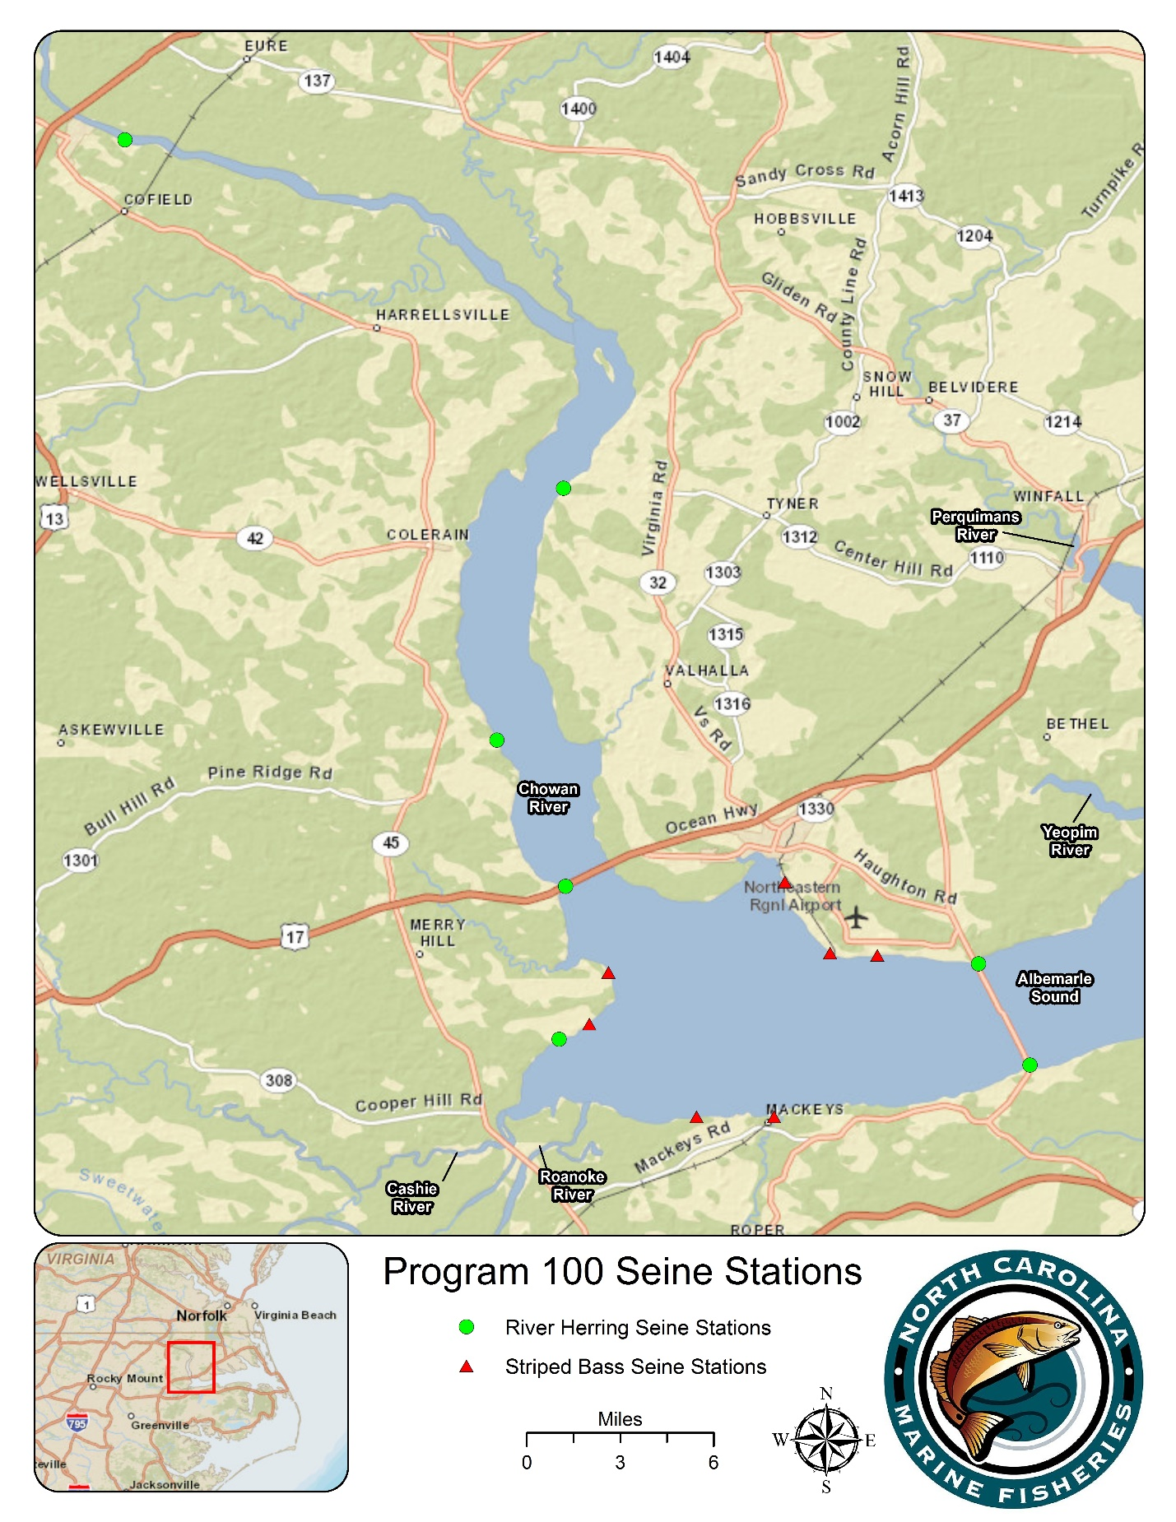

Figure 1. Program 100 river herring and striped bass seine stations, April 2020.